- 配置bean的细节

① scope 的说明:

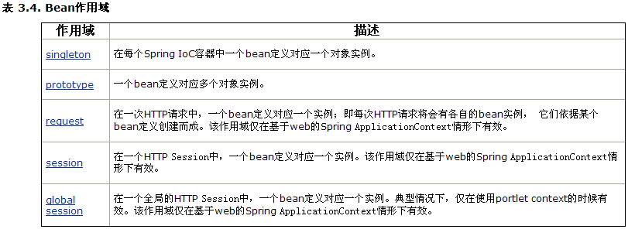
☞ 尽量使用 scope=”singleton” ,不要使用prototype,因为这样对我们的性能影响较大.

- 如何给集合类型注入值.
java中主要的集合有几种: map set list / 数组

Department类:
package com.hsp.collection;

import java.util.List;
import java.util.Map;
import java.util.Set;

public class Department {

private String name;
private String [] empName;
private List<Employee> empList;
private Set<Employee> empsets;
private Map<String,Employee> empMaps;

public Set<Employee> getEmpsets() {
return empsets;
}
public void setEmpsets(Set<Employee> empsets) {
this.empsets = empsets;
}
public String[] getEmpName() {
return empName;
}
public void setEmpName(String[] empName) {
this.empName = empName;
}
public String getName() {
return name;
}
public void setName(String name) {
this.name = name;
}
public List<Employee> getEmpList() {
return empList;
}
public void setEmpList(List<Employee> empList) {
this.empList = empList;
}
public Map<String, Employee> getEmpMaps() {
return empMaps;
}
public void setEmpMaps(Map<String, Employee> empMaps) {
this.empMaps = empMaps;
}

}

//Employeel类
package com.hsp.collection;
public class Employee {
private String name;
private int id;
public int getId() {
return id;
}
public void setId(int id) {
this.id = id;
}
public String getName() {
return name;
}
public void setName(String name) {
this.name = name;
}
}

beans.xml配置文件:
<?xml version="1.0" encoding="utf-8"?>
<beans xmlns="http://www.springframework.org/schema/beans"
xmlns:xsi="http://www.w3.org/2001/XMLSchema-instance"
xmlns:context="http://www.springframework.org/schema/context"
xmlns:tx="http://www.springframework.org/schema/tx"
xsi:schemaLocation="http://www.springframework.org/schema/beans http://www.springframework.org/schema/beans/spring-beans-2.5.xsd
http://www.springframework.org/schema/context http://www.springframework.org/schema/context/spring-context-2.5.xsd
http://www.springframework.org/schema/tx http://www.springframework.org/schema/tx/spring-tx-2.5.xsd">

<bean id="department" class="com.hsp.collection.Department">
<property name="name" value="财务部"/>
<!-- 给数组注入值 -->
<property name="empName">
<list>
<value>小明</value>
<value>小明小明</value>
<value>小明小明小明小明</value>
</list>
</property>
<!-- 给list注入值 list 中可以有相当的对象 -->
<property name="empList">
<list>
<ref bean="emp2" />
<ref bean="emp1"/>
<ref bean="emp1"/>
<ref bean="emp1"/>
<ref bean="emp1"/>
<ref bean="emp1"/>
<ref bean="emp1"/>
</list>
</property>
<!-- 给set注入值 set不能有相同的对象 -->
<property name="empsets">
<set>
<ref bean="emp1" />
<ref bean="emp2"/>
<ref bean="emp2"/>
<ref bean="emp2"/>
<ref bean="emp2"/>
</set>
</property>
<!-- 给map注入值 map只有key不一样，就可以装配value -->
<property name="empMaps">
<map>
<entry key="11" value-ref="emp1" />
<entry key="22" value-ref="emp2"/>
<entry key="33" value-ref="emp1"/>
</map>
</property>
<!-- 给属性集合配置 -->【点http协议 referer 】
<property name="pp">
<props>
<prop key="pp1">abcd</prop>
<prop key="pp2">hello</prop>
</props>
</property>
</bean>
<bean id="emp1" class="com.hsp.collection.Employee">
<property name="name" value="北京"/>
<property name="id" value="1"/>
</bean>
<bean id="emp2" class="com.hsp.collection.Employee">
<property name="name" value="天津"/>
<property name="id" value="2"/>
</bean>
</beans>
- 内部bean
<bean id=”foo” class=”....Foo”>
<property name=”属性”>
<!—第一方法引用-->
<ref bean=’bean对象名’/>
<!—内部bean-->
<bean>
<properyt></property>
</bean>
</property>
</bean>
- 继承配置

public class Student
public class Gradate extends Student

在beans.xml文件中体现配置
<!-- 配置一个学生对象 -->
<bean id="student" class="com.hsp.inherit.Student">
<property name="name" value="顺平" />
<property name="age" value="30"/>
</bean>
<!-- 配置Grdate对象 -->
<bean id="grdate" parent="student" class="com.hsp.inherit.Gradate">
<!-- 如果自己配置属性name,age,则会替换从父对象继承的数据 -->
<property name="name" value="小明"/>
<property name="degree" value="学士"/>
</bean>

思考: 目前我们都是通过set方式给bean注入值，spring还提供其它的方式注入值，比如通过构造函数注入值!

